

**Screenshot of Program:-**

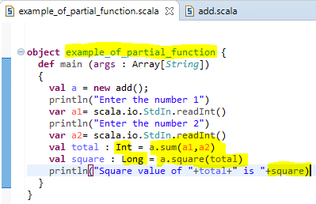

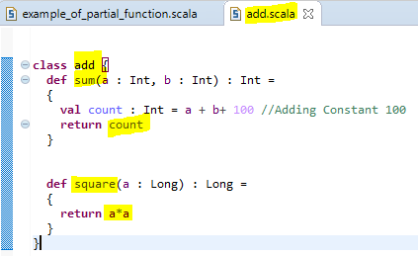

**SAMPLE OUTPUT 1:-**

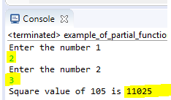

**SAMPLE OUTPUT 2:-**

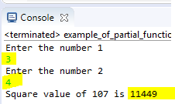

**PROGRAM CODE:-**

**add.scala:-**

**class** add {

**def** sum(a : Int, b : Int) : Int =

{

**val** count : Int = a + b+ 100 //Adding Constant 100

**return** count

}

**def** square(a : Long) : Long =

{

**return** a*a

}

}

**Example_of_partial_function.scala:-**

**object** example_of_partial_function {

**def** main (args : Array[*String*])

{

**val** a = **new** add();

println("Enter the number 1")

**var** a1= scala.io.StdIn.readInt()

println("Enter the number 2")

**var** a2= scala.io.StdIn.readInt()

**val** total : Int = a.sum(a1,a2)

**val** square : Long = a.square(total)

println("Square value of "+total+" is "+square)

}

}